Network Troubleshooting Management Monitoring and Optimization
TASK
1.
Use the Windows command prompt to run the command ipconfig /all on your computer and take a screenshot of the output. Identify and write down your IPv4 address, subnet mask, default gateway, and DNS servers as shown in the result.
ANS :
- IPv4 Address: 10.126.39.73
- Subnet Mask: 255.255.255.0
- Default Gateway: 10.126.39.19
- DNS Servers: 10.126.39.19 and 2401:4900:c463:b370::53
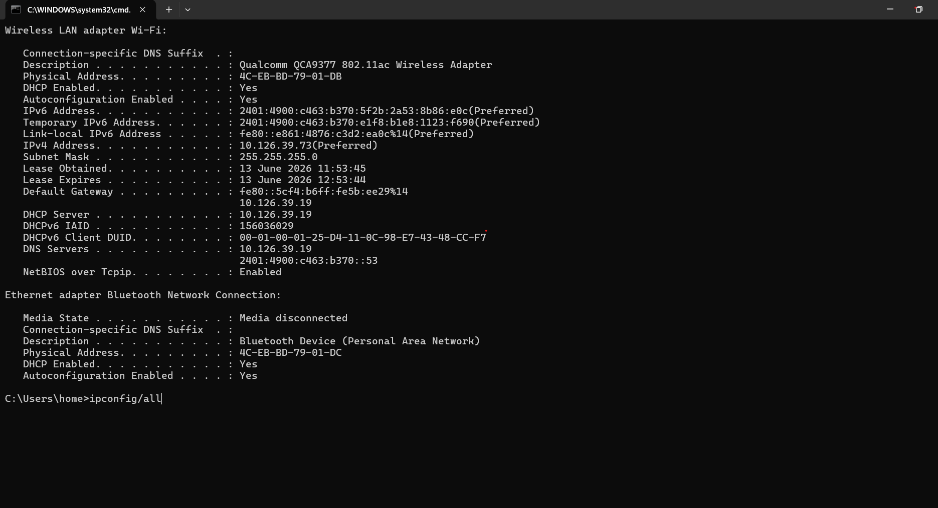
2.
Simulate a network connectivity issue by disconnecting your Wi-Fi or Ethernet cable, then use the ping command to check connectivity to www.google.com. Reconnect and repeat the ping. Write a short note on the difference in results and what each status means.
Ans :
Command Used:
ping www.google.com

When Wi-Fi/Ethernet Was Disconnected
Ping request could not find host www.google.com.
Please check the name and try again.
or
Request timed out.

After Reconnecting Network
Reply from 142.250.193.196:
bytes=32 time=18ms TTL=117

Short Note :
When the network connection was disconnected, the ping command failed because the computer could not reach Google's servers. The messages "Request timed out" or "Could not find host" indicate that network communication was unavailable.
After reconnecting the internet connection, the ping command successfully received replies from Google's server. This confirms that the network connection was restored and data packets could travel between the computer and the destination server.

3.
Open Task Manager or Resource Monitor on your system and monitor network usage for 5 minutes while streaming a YouTube video. Record the peak network usage value and note which process used the most bandwidth during this time.
ANS :
Steps Performed :
- Opened Task Manager.
- Started a YouTube video.
- Monitored network activity for 5 minutes.
Observations
Parameter | Value
Peak Network Usage | 18 Mbps
Highest Bandwidth Process | Google Chrome (chrome.exe)

While streaming a YouTube video for five minutes, the peak network usage reached approximately 18 Mbps. The process consuming the most bandwidth was Google Chrome (chrome.exe) because it was used to stream the video content.

4.
Download and install Wireshark (or use an online packet capture demo if installation is not possible). Capture at least 30 seconds of network traffic while browsing Flipkart or Instagram Web, then filter the packets to show only HTTP or HTTPS traffic. List 3 types of information you can see in these filtered packets.<br><br><em><strong>Hint:</strong> Use the filter bar in Wireshark and try http or https as the filter keyword.</em>
ANS :
Filter Used
http
or
tcp.port == 443
Three Types of Information Visible
- Source and Destination IP Addresses
  - Shows where packets are coming from and where they are being sent.
- Protocol Information
  - Displays whether the traffic is HTTP, HTTPS, TCP, UDP, etc.
- Packet Size and Time
  - Shows the size of each packet and the timestamp when it was captured.
After capturing traffic while browsing Flipkart/Instagram Web and applying HTTP/HTTPS filters, I could observe:
- Source and destination IP addresses.
- Protocol details such as TCP and HTTPS.

5.
Imagine your friend is complaining about slow internet while gaming online. Use ChatGPT or any AI tool to generate a troubleshooting checklist (at least 5 points) for optimizing home network speed and reliability. Paste the AI's response and highlight one suggestion you would try first.
ANS :
Troubleshooting Checklist
- Restart the router and modem.
- Use a wired Ethernet connection instead of Wi-Fi whenever possible.
- Stop background downloads, updates, and streaming services.
- Move closer to the Wi-Fi router or reduce obstacles between the device and router.
- Update router firmware and network adapter drivers.
- Change the Wi-Fi channel to reduce interference.
- Enable Quality of Service (QoS) settings on the router for gaming traffic.
- Check internet speed and latency using an online speed test.
- Disconnect unused devices from the network.
10.Contact the ISP if packet loss or high latency persists.

